AERS TRANSFORM

Week 15 Final Demonstration and Reassessment Pack
Integrated Human Review and Week 16 Handover v2.0
Six Module Evidence Consolidation | Final Simulation | Targeted Reassessment

Programme owner ASV Education Pvt. Ltd.
Authorised representative Mounesh CP AERS Facilitator
Understand First. Improve with Evidence.

Purpose and approved decision
Week 15 is the programme-wide performance gate after all six capability modules. The learner must demonstrate professional introduction, résumé discussion, role-specific reasoning, workplace response and interview performance in a realistic human-led setting. The pack records baseline-to-current improvement, any tightly controlled reassessment, and whether the evidence is ready for authorised Week 16 ERI review. It does not automatically issue ERI status or an Employability Passport.
Control | Approved value
Document ID | AERS-W15-FDR-002
Version | v2.0
Programme position | Week 15 of 16
Entry requirement | Modules 1 to 6 complete with compulsory evidence verified or an authorised documented exception
Primary demonstration | Final mock interview plus employer-style workplace simulation
Human authority | Panel scoring, moderation, reassessment and readiness decisions
Reassessment principle | Targeted, comparable and authorised; original result remains in the audit trail
Week 16 handover | Final ERI readiness and Passport evidence marked Ready or Action Required
Week 15 decision | Final demonstration complete; Complete with continuing development; Re-attempt authorised; or Hold and review

Week 15 outputs
- Six-module evidence consolidation and eligibility check.
- Final interview rubric, independent panel notes and consensus decision.
- Employer-simulation observation rubric and evidence record.
- Learner reflection, feedback acknowledgement and improvement commitment.
- Targeted reassessment record where authorised.
- Baseline-to-current comparison and Week 16 handover record.

Human authority boundary
The platform may schedule, capture, calculate, store and route records. It must not independently approve a reassessment, resolve an authenticity concern, declare final readiness, calculate a publishable ERI status without approved rules, or issue an Employability Passport. Those decisions require an authorised AERS reviewer and a retained audit trail.

Week 15 operating sequence
Stage | Activity | Required record | Decision owner
1 Entry gate | Confirm six-module completion, consent, accessibility and unresolved holds. | Eligibility and evidence checklist | AERS facilitator or reviewer
2 Preparation | Confirm target role, job description, panel, task and permitted support. | Final preparation file and administration record | Panel chair
3 Demonstration | Conduct professional introduction, résumé discussion, HR, behavioural and role-specific questions. | Final interview rubric and independent panel notes | Panel members
4 Workplace simulation | Observe role-relevant task, discussion or scenario. | Employer-simulation rubric and artefact | Qualified assessors
5 Reflection | Collect learner reflection and feedback acknowledgement. | Signed learner reflection | Learner and facilitator
6 Reassessment if needed | Authorise only a comparable, focused repeat under controlled conditions. | Reassessment plan, result and moderation record | Authorised reviewer
7 Handover | Record final Week 15 decision and readiness for ERI/Passport review. | Week 16 handover | Panel chair and authorised AERS reviewer

Entry and release rule
A missing quiz score alone does not replace the module-close decision. Entry is based on the approved module records: quizzes passed at 60 percent or above; each compulsory human-reviewed evidence item at least 6 out of 10; required revisions completed; feedback acknowledged; and no unresolved authenticity, privacy, consent, safety, recruitment-safety or factual hold. An authorised exception must name the reason, scope, owner and deadline.

Reassessment safeguard
Reassessment is not an unlimited retake. It is used when a procedural problem, a narrowly defined performance gap, an approved accommodation or insufficient comparable evidence prevents a defensible decision. The new task must assess the same capability at comparable demand. The original result is retained, and the reason, conditions, support, assessor, moderator and final decision are recorded.

AERS TRANSFORM v2.0
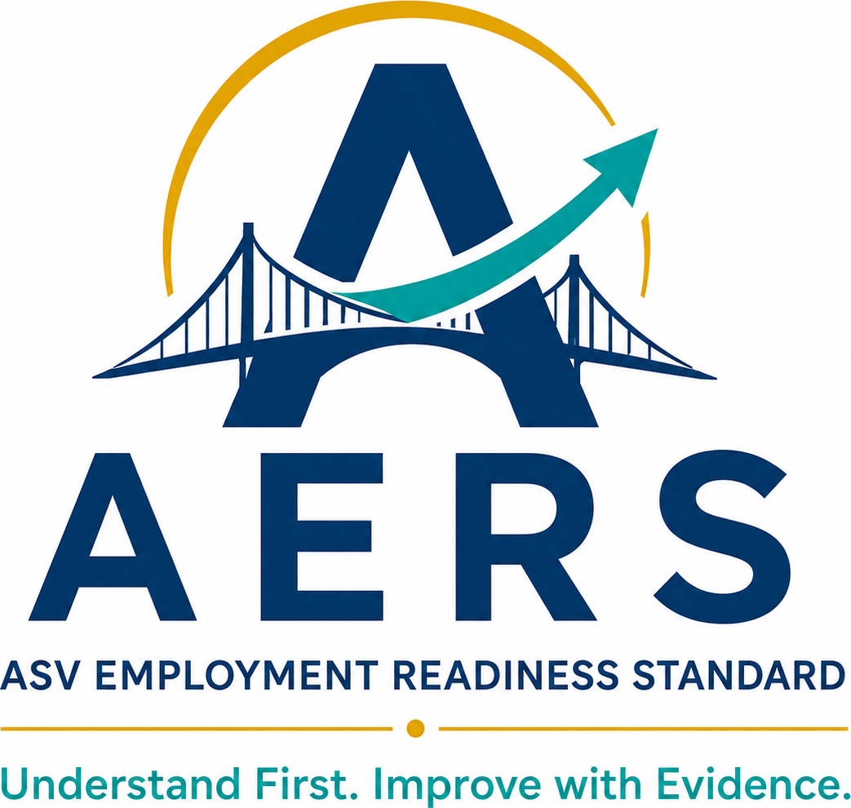

Week 15 Final Demonstration and Reassessment Pack
  - Final Demonstration and Employer Simulation
Final Demonstration
Duration | Final Result | Required Deliverable
Week 15 | Integrated employability performance demonstrated in a realistic selection setting | Final Interview Rubric + Panel Notes + Learner Reflection

Understand First. Improve with Evidence.
Prepared by ASV Education Pvt. Ltd. | Mounesh CP, AERS Facilitator

1. Week 15 Outcome and Completion Standard
Week 15 is the final performance demonstration before programme completion. The learner participates in a realistic panel interview and an employer-style task or discussion, using the verified evidence set from Week 14. Performance is independently observed, rubric-scored and followed by reflection and a readiness decision.
Outcome | Required Evidence | Completion Standard
Preparation | Verified role-fit preparation file | Role, logistics, evidence and support confirmed
Interview | Final panel mock + rubric | Relevant, concise, truthful and example-supported responses
Employer simulation | Task/discussion output + observation | Professional judgement, collaboration and ownership demonstrated
Reflection | Post-interview reflection | Learner identifies evidence, feedback and next action
Progression | Final readiness review | Week 16 handover recorded by human reviewers

Weekly time plan
Component | Time | Mode
Preparation and evidence check | 45 min | Platform/guided
Panel calibration | 20 min | Panel
Final mock interview | 30–40 min | Live
Employer task/discussion | 30–45 min | Live
Scoring, feedback and reflection | 45 min | Human-led

2. Final Simulation Principles and Safeguards
Principle | Required Practice
Realistic, not deceptive | Simulate selection without representing it as a job offer or employment guarantee.
Verified evidence only | Questions and claims use the Week 14 verified evidence set.
Comparable core prompts | All learners receive role-relevant core areas; probing may follow their evidence.
Independent observation | Panel members score before consensus discussion.
Fair access | Approved language/accessibility support is recorded; standards remain unchanged.
One re-attempt maximum | Only where procedure permits, with reason and new evidence documented.

Responsible-AI boundary
- AI may support permitted preparation and language practice when declared.
- AI cannot answer during the simulation, fabricate examples, impersonate the learner or replace panel judgement.
- Confidential employer/institution or learner data must not be entered into unauthorised tools.

3. Module 6 Handover and Final Evidence Check
Handover Item | Reference / Status | Final Action
Week 14 progression decision
Verified resume/version
Role/JD and organisation research
Requirement–evidence mapping
Interview evidence bank
Comparative improvement record
Continuing-development recommendation
Approved support/accommodation
Integrity/moderation issue

Release decision: □ Evidence set cleared □ Conditional action before simulation □ Hold and review

4. Role-Specific Final Preparation File
Preparation Field | Learner Record
Target role/title
Organisation/sector/context
Three role priorities
Six requirement–evidence mappings reference
Strongest verified project/example
Likely technical/functional question
Likely behavioural question
Development area and current action
Questions for panel/employer
Interview logistics and professional presence plan

Preparation improves relevance; it must not become a memorised script or unsupported persona.

5. Panel Composition, Roles and Conflict Check
Panel Member | Role / Organisation | Panel Responsibility | Conflict / Confidentiality
 |  | Chair / Assessor / Observer
 |  | Assessor / Observer
 |  | Institution/employer representative

Panel responsibilities
Stage | Required Action
Before | Review role, verified evidence, rubric, support record and core prompts.
During | Ask fair prompts, probe evidence, observe independently and record facts.
After | Score independently, discuss evidence, record consensus and feedback.
Safeguard | Avoid promises, discriminatory questions, coaching during scoring or unauthorised disclosure.

Institution/employer participation: □ Available □ Institution panel only □ Alternative qualified panel documented

6. Panel Calibration and Scoring Anchors
Criterion | 1 — Needs Support | 2 — Developing | 3 — Ready | 4 — Strong
Role fit/preparation | Little relevant preparation | General preparation | Relevant, evidence-led fit | Insightful and prioritised fit
Response relevance | Frequently off-task | Partly answers prompt | Direct and appropriately detailed | Precise and adaptive
Evidence credibility | Unsupported/inconsistent | Some evidence; gaps remain | Specific verified evidence | Strong evidence under probing
Structure/clarity | Difficult to follow | Partly structured | Logical and understandable | Concise and flexible
Professional interaction | Inappropriate/passive | Inconsistent interaction | Attentive and professional | Confident, respectful rapport
Judgement/reflection | Weak or unsafe judgement | Basic judgement | Responsible action and learning | Nuanced judgement and transfer

Calibration rule
Panel members discuss sample anchors before the first learner, then score each learner independently. Understandable regional accent is not penalised.

7. Final Mock Interview Run Sheet
Stage | Core Prompt Area | Purpose | Time
Opening | Professional introduction and role motivation | Relevance and presence | 4 min
Role fit | Why this role/organisation? | Preparation and fit | 5 min
Capability | Verified project/task contribution | Evidence and ownership | 8 min
Behaviour | Challenge, teamwork or feedback example | Behaviour and learning | 7 min
Situation | Employer/workplace judgement scenario | Decision and communication | 6 min
Closure | Learner questions and final summary | Professional closure | 4 min

Administration record
Scheduled / Actual Time | Task/Prompt Version | Support Used | Incident / Note

8. Structured Interview Question Bank
Area | Core Prompt | Evidence Probe
Motivation | Why are you interested in this role? | Which requirement best matches your evidence?
Project/capability | Describe your most relevant project or task. | What exactly did you do and how was the result verified?
Problem solving | Tell us about a difficult problem. | What alternatives did you consider?
Teamwork | Describe a disagreement or team challenge. | How did your action help the work progress?
Feedback/learning | Describe feedback that changed your work. | What evidence shows you applied it?
Ethics/judgement | What would you do if you found an error or privacy risk? | When and to whom would you escalate?
Development | What capability are you improving now? | What is your current plan and evidence?
Closure | What would you like to ask us? | What matters most in your decision?

Use role-appropriate wording. Do not ask discriminatory, intrusive or unrelated personal questions.

9. Final Interview Rubric and Evidence Record
Criterion | Weight | Score 1–4 | Weighted Result | Observed Evidence
Role fit and preparation | 15%
Response relevance | 15%
Verified evidence/ownership | 20%
Structure and clarity | 15%
Professional interaction/listening | 15%
Judgement and adaptability | 15%
Closure and next-step communication | 5%

Overall result
Panel Total | Readiness Decision | Evidence Reference
 | Ready / Ready with development / Not yet ready / Invalid

The panel decision must follow recorded evidence. Confidence, accent, personal similarity or one impressive answer cannot replace the full rubric.

10. Panel Notes and Independent Scoring
Panel Member | Strength Evidence | Gap / Risk Evidence | Independent Decision

Consensus record
Discussion Item | Consensus / Dissent Record
Material strengths
Material gaps or risks
Score difference requiring calibration
Continuing-development recommendation
Final decision and rationale

Panel chair: ____________________ Date: __________

11. Employer-Style Task or Discussion Brief
Simulation Field | Brief
Selected format | □ Individual work task □ Case discussion □ Group discussion □ Role-play
Role/context
Task/problem statement
Information/resources supplied
Expected output
Time limit
Collaboration rules
Evaluation criteria | Professional judgement, communication, ownership, teamwork and ethics
Accessibility/support

Task design checks
- Relevant to early-career work and feasible within the allotted time.
- Does not require confidential employer information or unpaid productive work.
- Allows observable individual contribution.
- Uses clear instructions, fair resources and a stated scoring method.

12. Employer Simulation Observation Rubric
Criterion | 1 — Needs Support | 2 — Developing | 3 — Ready | 4 — Strong | Evidence
Task understanding | Misunderstands core task | Partial understanding | Clarifies and addresses task | Prioritises ambiguity/risk
Problem solving | Unstructured/unsafe | Basic approach | Logical and feasible approach | Insightful options/trade-offs
Communication | Unclear/inappropriate | Partly clear | Clear and professional | Concise and audience-aware
Ownership | Avoids/oversteps responsibility | Inconsistent ownership | Acts within role and follows through | Proactive with boundaries
Collaboration | Disrupts/withdraws | Uneven contribution | Listens and contributes | Enables group progress
Ethics/judgement | Ignores material risk | Recognises some risk | Protects people/data and escalates | Balances risk and action well

Simulation total: ____ / 24 Decision: □ Ready □ Ready with development □ Not yet ready □ Invalid

13. Professional Presence and Next-Step Communication
Observed Behaviour | Evidence / Feedback
Punctuality and readiness
Professional greeting/introduction
Listening and clarification
Verbal/non-verbal composure
Respectful interaction
Questions for panel
Closing summary/thanks
Post-interview follow-up message

Follow-up message planner
Element | Learner Draft
Professional subject/greeting
Thank-you and role reference
One relevant fit/evidence point
Next-step/availability close

14. Learner Post-Interview Reflection
Reflection Prompt | Learner Response
Which response best demonstrated my readiness?
Which verified evidence did I use effectively?
Where did probing expose a gap?
How did I respond in the employer simulation?
What feedback is most important?
What will I retain for future interviews?
What will I continue developing?
What evidence should appear in my Week 16 Passport?

Responsible-AI declaration
□ No AI used in preparation □ AI used as permitted for: ____________________. No AI was used to answer during the scored simulation or fabricate evidence.

15. Re-Attempt and Final Readiness Decision
Re-Attempt Control | Record
Procedure permits one re-attempt? | Yes / No
Material reason
Original result retained
Specific dimension/task to repeat
Corrective preparation allowed
New prompt/version and conditions
Re-attempt result/evidence
Decision reason

A re-attempt is not automatic and cannot erase the original record. It must address a documented procedural or narrowly defined performance issue under approved conditions.
Final Dimension | Decision
Interview performance | Ready / Ready with development / Not yet ready / Invalid
Employer simulation | Ready / Ready with development / Not yet ready / Invalid
Verified evidence/integrity | Clear / Conditional / Hold
Overall Week 15 readiness | Demonstrated / Continuing development / Further review

16. Week 16 Handover and Institutional Review
Week 16 Input | Status / Reference | Required Action
Final interview rubric | Complete / Conditional / Missing
Panel notes and decision | Complete / Conditional / Missing
Employer simulation rubric | Complete / Conditional / Missing
Learner reflection | Complete / Conditional / Missing
Verified evidence set | Complete / Conditional / Hold
Continuing-development recommendation | Complete / N/A
Final ERI readiness | Ready / Action required
Employability Passport evidence | Ready / Action required

Institutional observation
Review Question | Finding / Recommendation
Can institution or employer representatives participate in final simulation?
Are panel scoring and employer-task observations sufficiently independent?
Does the simulation reflect realistic early-career selection?
Are fairness, privacy and support boundaries clear?
Is the Week 16 handover complete and decision-useful?

Completion decision: □ Final demonstration complete □ Complete with continuing development □ Re-attempt authorised □ Hold/review
Learner: __________________ Panel chair: __________________ Institution/employer observer: __________________ Date: __________
Document control: Week 15 Final Demonstration and Reassessment Pack v2.0. Final simulation evidence feeds Week 16 Final ERI, Employability Passport and 30 60 90 Day Progression Plan.

Week 15 v2.0 Consolidation and Reassessment Annexes
These annexes connect the final simulation to the six regenerated module masters and create the controlled evidence trail required for the Week 16 ERI, Employability Passport and 30 60 90 Day Progression Plan decisions.

Six Module Evidence Consolidation
Module | Verified close evidence | Status | Reviewer and date | Open action
1 Career Clarity | Verified Career Direction Plan and Career Clarity Evidence Portfolio
2 Résumé Readiness | Verified Résumé Portfolio Version 2
3 Communication Readiness | Verified Communication Evidence Portfolio Version 2
4 Aptitude and Problem Solving | Verified Aptitude Evidence Portfolio Version 2
5 Workplace Readiness | Verified Workplace Readiness Evidence Portfolio Version 2
6 Interview Readiness | Verified Interview Readiness Portfolio Version 2
Release status: ☐ Cleared for final demonstration ☐ Conditional action before demonstration ☐ Hold and authorised review

Baseline to Current Performance Comparison
Capability | Baseline evidence and observation | Current evidence and observation | Change demonstrated | Reviewer conclusion
Career direction and role alignment
Résumé and evidence articulation
Communication and professional interaction
Aptitude and problem-solving reasoning
Workplace behaviour and scenario response
Interview and selection performance
Comparison rule: record observable change and retained evidence. Do not infer improvement from attendance, confidence or completion alone.

Integrated Final Demonstration Evidence Index
Evidence item | File or record reference | Version and date | Human decision | Notes
Professional introduction
Résumé discussion
HR and motivation responses
Behavioural or STAR response
Role-specific reasoning
Workplace scenario or employer-style task
Learner questions and follow-up communication
Learner reflection and feedback acknowledgement

Priority Capability Reassessment Referral
Referral field | Approved record
Capability or dimension
Original task, evidence, score and date
Specific reason reassessment is required
Why existing evidence is insufficient
Comparable reassessment task and version
Standard and threshold retained
Permitted preparation and tools
Approved support or accommodation
Assessor and moderator
Date, time, location or platform
Evidence and audit records to retain
Authorisation: ☐ Approved ☐ Revise plan ☐ Held pending clarification
Authorising reviewer: ____________________ Date: __________

Comparability and Fairness Check
Dimension | Original or reference task | Reassessment task | Match or required action
Capability assessed
Behavioural or cognitive demand
Complexity and difficulty
Number and type of prompts
Time pressure
Information and resources provided
Scoring criteria and threshold
Opportunity to demonstrate evidence
Accessibility or accommodation
Fairness decision: ☐ Comparable and approved ☐ Comparable with documented adjustment ☐ Not comparable and redesign required

Reassessment Observation and Decision Record
Record field | Entry
Reassessment task version
Assessor and moderator
Conditions and permitted support confirmed
Observed performance and evidence
Rubric result
Integrity, privacy or safety concern
Comparison with original performance
Final decision and reason
Continuing-development action
Final reassessment decision: ☐ Demonstrated ☐ Demonstrated with continuing development ☐ Not yet demonstrated ☐ Invalid or hold
Assessor signature: ____________________ Moderator signature: ____________________ Date: __________

Learner Feedback Acknowledgement and Commitment
I have received the final demonstration feedback and understand the evidence used in the decision. I have had an opportunity to clarify the feedback. I understand that Week 15 completion does not guarantee employment and does not automatically issue an ERI status or Employability Passport.
My strongest demonstrated capability is ____________________. My continuing-development priority is ____________________. The first action I will complete before or within my 30 60 90 Day Progression Plan is ____________________ by ____________________.
Learner name and signature: ____________________ Date: __________
Facilitator or reviewer acknowledgement: ____________________ Date: __________

Week 16 Readiness Handover
Handover component | Ready | Action required | Evidence or action
Six module-close decisions | ☐ | ☐
Final interview rubric and panel notes | ☐ | ☐
Employer-simulation rubric and artefact | ☐ | ☐
Learner reflection and acknowledgement | ☐ | ☐
Reassessment record where applicable | ☐ | ☐
Authenticity and Responsible-AI controls clear | ☐ | ☐
Consent, privacy and accessibility controls clear | ☐ | ☐
Baseline-to-current comparison complete | ☐ | ☐
Final ERI review evidence sufficient | ☐ | ☐
Employability Passport evidence sufficient | ☐ | ☐
Week 15 decision: ☐ Final demonstration complete ☐ Complete with continuing development ☐ Re-attempt authorised ☐ Hold and review
Week 16 release: ☐ Released for authorised ERI review ☐ Released with named action ☐ Not released
Panel chair: ____________________ AERS authorised reviewer: ____________________ Date: __________

Platform Status and Decision Controls
Status | Meaning | System behaviour
Eligible | Entry evidence cleared. | Allow scheduling; preserve eligibility record.
Scheduled | Panel, task and conditions confirmed. | Notify authorised participants only.
In Progress | Final demonstration is underway. | Lock task version and start audit events.
Evidence Submitted | Required records captured. | Route to independent panel scoring.
Moderation Required | Scores, integrity or fairness require review. | Block final handover.
Reassessment Authorised | Focused comparable repeat approved. | Create linked reassessment version; retain original.
Complete | Final demonstration requirements satisfied. | Allow Week 16 handover, not automatic ERI or Passport.
Complete with Continuing Development | Minimum demonstration complete with documented development action. | Allow conditional Week 16 handover by authorised decision.
Hold and Review | Authenticity, privacy, safety, consent, fairness or evidence concern. | Block Week 16 release and escalate.

Final Quality and Moderation Checklist
☐ Entry decision and all six module records are traceable
☐ Panel members completed conflict and calibration checks
☐ Interview and employer-simulation prompts were role relevant and fair
☐ Panel members scored independently before consensus
☐ Regional accent, disability or personal similarity did not influence scoring
☐ All material evidence and task versions are retained
☐ Responsible-AI declaration is complete
☐ Any reassessment was authorised, comparable and linked to the original result
☐ Learner reflection and feedback acknowledgement are signed
☐ Week 16 release decision is recorded by an authorised reviewer
☐ No unresolved authenticity, privacy, consent, accessibility, safety or factual hold

Version Control and Approval
Field | Record
Version | v2.0
Regeneration date | 17 September 2026
Content basis | Approved Week 15 Final Mock Interview and Employer Simulation Delivery Pack v1.0 plus revised six-module architecture
Primary change | Added six-module consolidation, baseline comparison, targeted reassessment controls and Week 16 release gate
Decision authority | Authorised human panel, assessor, moderator and AERS reviewer
Next stage | Week 16 Final ERI, Employability Passport and 30 60 90 Day Progression Plan
Change control | Changes to tasks, evidence, rubrics, thresholds, reassessment or decision categories require a new approved version
Prepared or facilitated by: Mounesh CP ____________________ Date: __________
Programme approval: ______________________________________ Date: __________
Institution acknowledgement: ______________________________ Date: __________

